CONFIDENTIAL PATIENT INFORMATION

PATIENT INFORMATION Date______________

Name____________________________________ Male □ Female □ Social Security #_________________ Birthdate__________ Age_____ Single□ Married□ Widowed□ Separated□ Divorced□ Children?______ Address___________________________________________City/State/Zip__________________________________

Phone numbers: Home____________________ Mobile_______________________ Work ______________________

EMAIL___________________________________________________

Patient’s occupation_________________________________Employer______________________________________ Employer address/city/state/zip______________________________________________________________________

SPOUSE □ PARENT □ LEGAL GUARDIAN □ (check one)

Name____________________________________ Male □ Female □ Social Security #_________________ Birthdate__________ Age_____ Single □ Married □ Widowed □ Separated □ Divorced □ Children?______ Address___________________________________________City/State/Zip___________________________________

Home phone_______________________________________ Work phone____________________________________

Patient’s occupation_________________________________Employer______________________________________ Employer address/city/state/zip______________________________________________________________________

How were you referred to our office?__________________________________________________________________

INSURANCE

Who is responsible for this account?____________________________Relation to Patient_______________________

Patient’s Insurance________________________________ Spouse’s Insurance________________________________

Name of Ins._____________________________________ Name of Ins._____________________________________

Address_________________________________________Address_________________________________________

Policy #_________________________________________Policy #_________________________________________

Group # ________________________________________Group #__________________________________________ Phone #_________________________________________Phone #_________________________________________

INSURANCE INFORMATION

I understand and agree that health and accident insurance policies are an agreement between an insurance carrier and myself. Furthermore, I understand that Sullivan Family Chiropractic will prepare any necessary reports and forms to assist me in making collection from the insurance company and that any amount authorized to be paid directly to Sullivan Family Chiropractic will be credited to my account upon receipt. I also give Sullivan Family Chiropractic power of attorney to endorse checks made out to me, to be credited to my account. However, I clearly understand and agree that all services rendered to me are charged directly to me and that I am personally responsible for payment. I also understand that if I suspend or terminate my care and treatment, any fees for professional services rendered to me will be immediately due and payable.

Patient’s Signature______________________________________________________Date__________________________________________

CONSENT OF PROFESSIONAL SERVICES AND RELEASE OF INFORMATION

I hereby authorize and release Dr. Sullivan and whomever he/she may designate as his assistants to administer treatment, physical examination, X-ray studies, laboratory procedures, chiropractic care or any other services that he deems necessary in my case. I further authorize Dr. Sullivan to disclose all or any part of my patient record to any person or corporation which is or may be liable under a contract to Sullivan Family Chiropractic or to the patient or to a family member or employer of the patient for all or part of the services rendered to me, including and not limited to, hospital or medical service companies, insurance companies, worker’s compensation carriers, welfare funds or employers.

Patient’s Signature______________________________________________________Date__________________________________________

IF A MINOR-Signature of Parent/Guardian__________________________________________Date_________________________________

Patient’s Name______________________________________ DATE_______________
HEALTH QUESTIONAIRE - CURRENT CONDITION
Describe your symptoms/location of problems?____________________________________________________________________________
Your goals for treatment/what do you want to be able to do that you currently cannot:_____________________________________________
Date symptoms first appeared?________________Is this related to an automobile or work-related accident?______________

What caused your pain to begin?________________________________________________________________________________________

What treatment, tests, xrays, and/or medications have you already received for your condition?
___________________________________________________________________________________________________________________
Other doctors seen for this condition:_____________________________________________________________________________________
Rate the severity of your pain on a scale from 1 (least pain) to 10 (severe pain)__________________
Type of pain (mark all that apply): □ sharp □ dull □ throbbing □ numbness □ aching □ burning □ shooting □ tingling □ cramps □ stiffness □ swelling □ other
How often are your symptoms present: □ constant □ frequent □ occasional □ intermittent (comes and goes)
Since it began, is your problem: □ improving □ no change □ getting worse
What makes the problem better ?________________________________________________________________________________________
What makes the problem worse ?________________________________________________________________________________________
Can you perform your daily home activities? □ yes □ yes, limited by myself □ yes, only with help □ not at all
Can you perform your daily work activities? □ yes □ yes, limited by myself □ yes, only with help □ not at all
Describe your daily job requirements:____________________________________________________________________________________
Your stress level: □ none □ mild □ moderate □ severe
PAST HEALTH HISTORY

Have you been treated by a doctor or health care professional in the last year?____ If yes, for what conditions: ___________________________________________________________________________________________________________________
Have you ever been under chiropractic care before?________ Where:___________________________________________________________
Same condition? _________ Other __________________________________________

If you have ever had a listed symptom in the past, please check the symptom in the past column. If you are presently experiencing a particular symptom, check that symptom in the present column. KNOWLEDGE OF THESE CONDITIONS MAY INFLUENCE THE TYPE OF TREATMENT OR THERAPY YOU ARE TO RECEIVE.
Past Present Condition Past Present Condition Past Present Condition
□ □ Neck pain □ □ Heartburn/Indigestion □ □ General fatigue
□ □ Shoulder pain R□ L□ □ □ Dermatitis/Eczema/Rash □ □ Irregular menstrual cycle
□ □ Pain in upper arm or elbow R□ L□ □ □ Numbness □ □ Abdominal pain
□ □ Hand pain R□ L□ □ □ Nosebleeds □ □ Breast soreness □ lumps □
□ □ Wrist pain R□ L□ □ □ Depression □ □ Endometriosis
□ □ Upper back pain □ □ Aortic Aneurysm □ □ PMS
□ □ Low back pain □ □ Heart Attack (date)________ □ □ Loss of bladder control
□ □ Pain in upper leg or hip R□ L□ □ □ Stroke (date)_____________ □ □ Painful urination
□ □ Pain in lower leg or knee R□ L□ □ □ Cancer, explain below □ □ Frequent urination
□ □ Pain in ankle or foot R□ L□ □ □ Tumor, explain below □ □ Excessive bowel action
□ □ Jaw pain □ □ Asthma □ □ Constipation
□ □ Swelling, stiffness of joint(s) □ □ Prostate problems Avg.# of bowel movements per day____
If a family member has had any of the following,
please mark the appropriate box:
□ Cancer □ Epilepsy □ Rheumatoid
□ Diabetes □ Heart problems □ Lung problems
□ Stroke □ Mental problems □ Back problems
□ Other_______________
Relationship to patient
__________________________________________
□ □ Pain that wakes you at night □ □ Blood disorder □ □ HIV/AIDS
□ □ Fainting □ □ Emphysema (chromic lung disorders) □ □ Difficulty breathing
□ □ Visual Disturbance □ □ Arthritis □ □ Other_______________________
□ □ Convulsions □ □ Rheumatoid Arthritis
□ □ Dizziness □ □ Diabetes
□ □ Headache □ □ Epilepsy
□ □ Muscular Incoordination □ □ Ulcer
□ □ Tinnitus (ringing or noises in ear) □ □ Liver/gallbladder problem
□ □ Rapid Heart Beat □ □ Kidney stones
□ □ Chest pain □ □ Hepatitis
□ □ Loss of Appetite □ □ Bladder Infection
□ □ Anorexia □ □ Kidney Disorders
□ □ Abnormal weight loss □ □ Colitis/Irritable Colon
□ □ Abnormal weight gain □ □ Excessive thirst
□ □ Chronic cough □ □ Chronic sinusitis (sinus infections)
Please check all that apply to you:
□ currently pregnant □ # of births_________ □ Tobacco □ Alcohol □ Drug or alcohol dependence

CURRENTMEDICATIONS/HOSPITALIZATIONS/SURGERIES:_________________________________________________________
PRIMARY CARE PHYSICIAN: NAME/LOCATION____________________________________________________________

I AUTHORIZE DR. SULLIVAN TO SEND A MEDICAL UPDATE OF MY CURRENT CONDITION TO MY PRIMARY CARE PHYSICIAN Signature____________________________________

INFORMED CONSENT

I hereby request and consent to the performance of chiropractic adjustments and other chiropractic procedures, including various modes of physical therapy and diagnostic X-rays, on me (or on the patient named below, for whom I am legally responsible) by the doctor of chiropractic named below and/or other licensed doctors of chiropractic who now or in the future work at the clinic or office listed below or any other office or clinic.
I have had an opportunity to discuss with the doctor of chiropractic named below and/or with other office or clinic personnel the nature and purpose of chiropractic adjustments and other procedures. I understand that results are not guaranteed.
I understand and am informed that, as in the practice of medicine, in the practice of chiropractic there are some risks to treatment, including but not limited to fractures, disc injuries, strokes, dislocations and sprains. I do not expect the doctor to be able to anticipate and explain all risks and complications, and I wish to rely upon the doctor to exercise judgment during the course of the procedure which the doctor feels at the time, based upon the facts then known to him or her, is in my best interest.
I have read, or have had read to me, the above consent. I have also had an opportunity to ask questions about its content, and by signing below I agree to the above-named procedures. I intend this consent form to cover the entire course of treatment for my present condition and for any future condition(s) for which I seek treatment.

Patient/guardian Signature_________________________________ Date ____________
Witness Signature ________________________________ Date_____________

HEALTH CARE AUTHORIZATION FORM

This form authorizes us to file your insurance, have your signature on file for insurance purposes, comply with Health Insurance Portability and Accountability Act (HIPAA) regulations, and provide you with better overall service. THE PATIENT IDENTIFIED BELOW AUTHORIZES SULLIVAN FAMILY CHIROPRACTIC TO USE AND OR DISCLOSE PROTECTED HEALTH INFORMATION IN ACCORDANCE WITH THE FOLLOWING:

- I give Sullivan Family Chiropractic permission to treat me in an area where other patients are also being treated. I give permission to use my name aloud in the office during my visit (Including but not limited to, general conversation with me, calling me from the waiting area, taking me to treatment room). I am aware that other persons may overhear some of my protected health information during the course of care. Please hold any private information or questions until you are in a private room with the staff or doctor. (It is our office policy to not discuss health information and private issues in front of other patients, all precautions will be made to adhere to this policy.)

- I authorize the use of my name in print for general purpose; such as posting my name on an internal Referral Board if and when I refer people to their office for evaluation and treatment, patient of the month listing, etc. I further authorize the use of my signature to be on a universal (consecutively viewed by each patient signing in) sign in sheet for each visit.

- I authorize Sullivan Family Chiropractic to use my address, phone numbers and clinical records to contact me with appointment reminders, to leave a message, to reschedule an appointment, missed appointment notification, birthday cards, newsletters, holiday cards, or other health related information. If I am contacted by phone, I give permission to leave a message with a member of my household, on my answering machine or voice mail.

- I authorize use of this form on all of my insurance submissions [SIGNATURE ON FILE] I authorize release of information to all my insurance companies. I authorize Sullivan Family Chiropractic to act as my agent in helping me obtain payment from my insurance companies. I authorize payment direct to Sullivan Family Chiropractic from my insurance companies.

- I understand that I am ultimately responsible for my bill and payment is due when services are rendered, unless other arrangements have been made.

- I permit a copy of this authorization to be used in place of the original.

- I understand that this office is complying with federal HIPAA guidelines by advising me that they are doing everything in their power to protect my private health information. At any time, I am able to ask this office of the safety and protected nature of my health information, or any other related issues or concerns.

- By signing this form I am giving Sullivan Family Chiropractic permission to use and disclose my protected health information in accordance with the directives listed above.

Name (Please print)_________________________________________ Date of Birth _________________

Signature__________________________________________________ Date________________________

GENERAL PAIN DISABILITY INDEX
The rating scales below are designed to measure the degree to which several aspects of your life are presently disrupted by chronic pain. In other words we would like to know how much your pain is preventing you from doing what you would normally do. Respond to each category indicating the overall impact of pain in your life, not just when the pain is at its worst.

For each of the six categories or daily living listed, PLEASE NUMBER EACH ITEM WITH A SCORE OF 0-10 WHICH BEST DESCRIBES YOUR TYPICAL LEVEL OF ACTIVITIES. A score of 0 means no limitations at all and a score of 10 signifies that all of the activities in which you would normally be involved have been totally disrupted or prevented by your pain.
0 1 2 3 4 5 6 7 8 9 10
NO LIMITATION TOTAL LIMITATION COMPLETELY ABLE TO FUNCTION UNABLE TO FUNCTION

____1. Family/Home Responsibilities-Chores and duties performed around the house (ex. Yard work, carpool, etc.)
____2. Recreation-Hobbies, sports, and other similar leisure time activities.
____3. Social Activity-Participation with friends and family. Parties, theater, concerts, dining out and other social functions.
____4. Occupation-Directly related to your job. Full, part, or non-paid positions; including homemaker.
____5. Self Care-Personal maintenance and independent daily living (ex. Taking a shower, driving, getting dressed, etc.)
____6. Life-Support Activity-Eating, sleeping, and breathing.

_____ ________________________________________________ ______________
Total Signature Date

VISUAL ANALOG PAIN SEVERITY SCALE (VAS SCALE)

INSTRUCTIONS: Please mark on the line below how you currently feel.

NO PAIN-------------------------------------------------------WORST PAIN EVER

PLEASE MARK ON THE BODIES TO THE LEFT, THE LOCATION AND TYPE OF PAIN YOU ARE EXPERIENCING
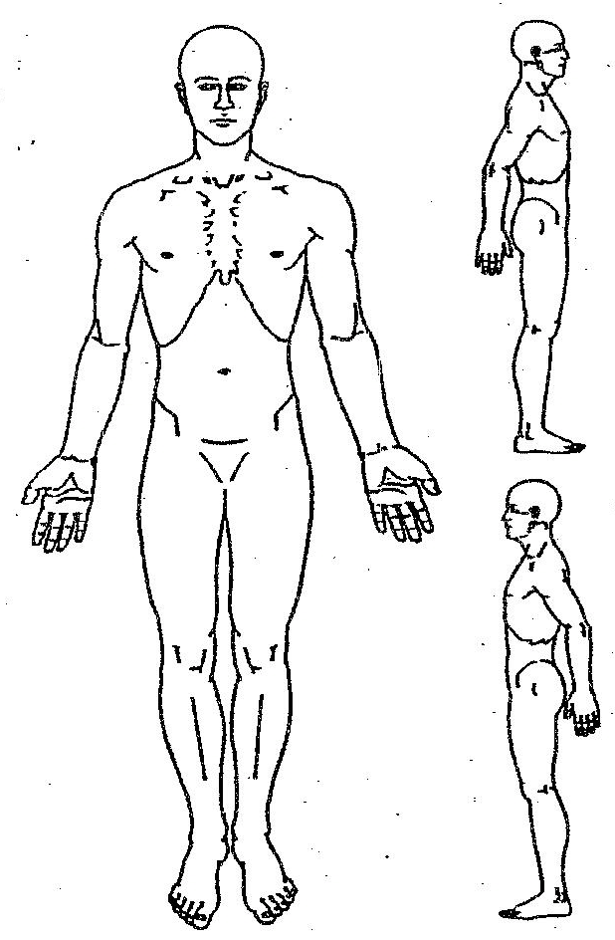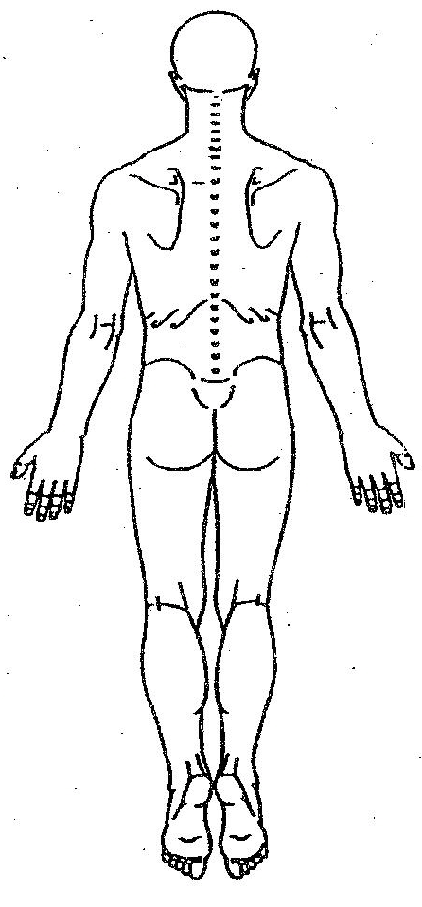
NUMBNESS ====
BURNING XXXXX
SHARP/STABBING ///////
PINS AND NEEDLES ooooo
ACHING aaaaa

